Parth Babbar

9999940289   kishibabbar@gmail.com

Evolution of us banking technology & resilience during economic crises

**Introduction:**

Banking technology has evolved significantly during this past century, moving from handwritten ledger entries to advanced digital systems. This progress has significantly improved the efficiency, security, and accessibility of financial services. Furthermore, the resilience of the US banking system has been challenged during several economic crises, demanding reforms and innovations to stabilise and improve financial infrastructure.

**Evolution of Banking Technology:**

There were many phases involved in the evolution of the banking technology few among them are mentioned below:

1. **Early Banking Techniques:** In the early 20th century, banking activities were primarily manual. The key technologies were:  
    **1. Ledger Books:** To track transactions handwritten entries were made.  
    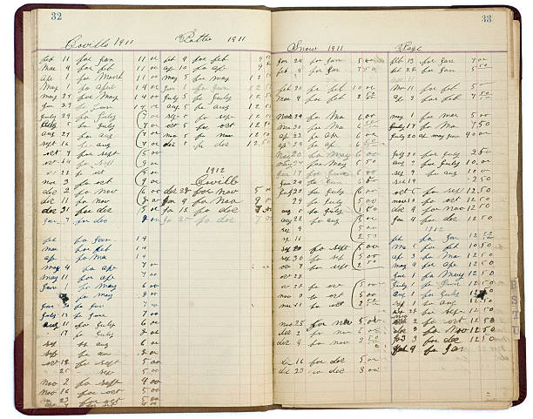  
    **2. Check Processing:** Checks are manually cleared and settled.  
      
    **3. Telegraph Networks:** Used to provide quick communication between banks, particularly for financial transfers.  
    
2. **Chartered Banks & the Federal Reserve System:** The early twentieth century was an innovative age for United States banking, notably with the founding of the Federal Reserve System:  
    **1. Chartered Banks:** Banks chartered by the federal or state governments are subject to various rules. This approach paved the way for a more standardised banking environment.  
    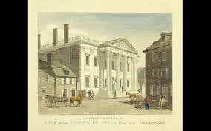  
    **2.Federal Reserve Act:** Founding of Federal Reserve Act(1913), which provided the United States with a central banking institution to monitor monetary policy, stabilise the financial system, and act as a lender of last resort.  
    A black and white logo

   Description automatically generated  
    **3.Federal Reserve Banks:** Twelve regional Federal Reserve Banks were formed to operate under the Federal Reserve Board's supervision, providing nationwide liquidity and financial stability.  
    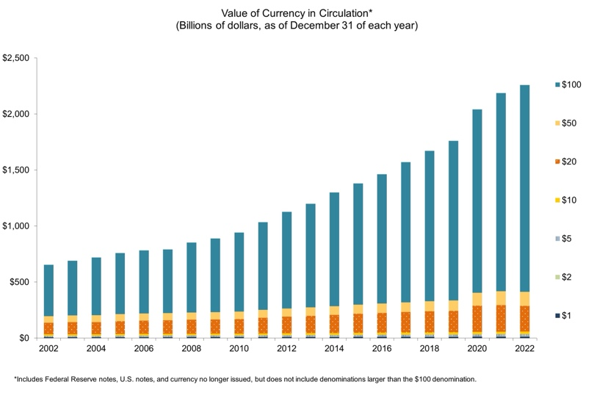
3. **The Introduction of Computerization:** The mid-20th century witnessed the debut of computers in banking:  
    **1. Mainframe Computers:** In the 1950s and 1960s, banks began to adopt mainframe computers for mass transaction processing and record keeping. This enabled the quicker and more accurate processing of massive amounts of data.  
    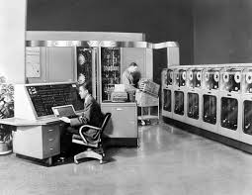  
    **2. Automated Teller Machines(ATM):** ATMs, which were first introduced in the 1960s and became widespread in the 1970s, transformed cash withdrawal and balance checking by offering 24-hour access to these services.  
    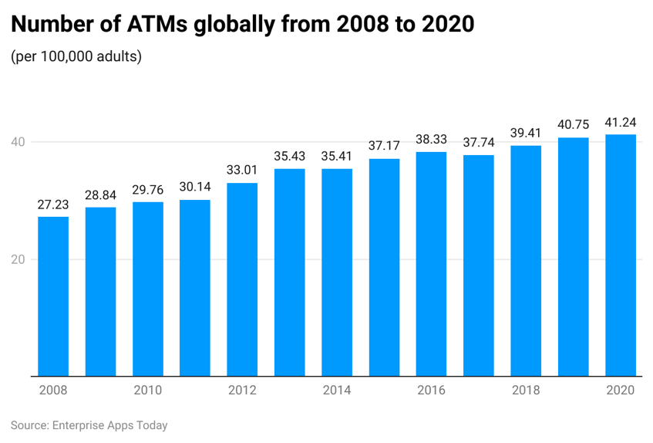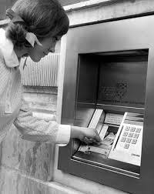  
    **3.Electronic Fund Transfer(EFT):** In the 1970s, EFT systems permitted the electronic transfer of funds between accounts, decreasing the need for paper transactions and allowing for speedier payment processing.  
    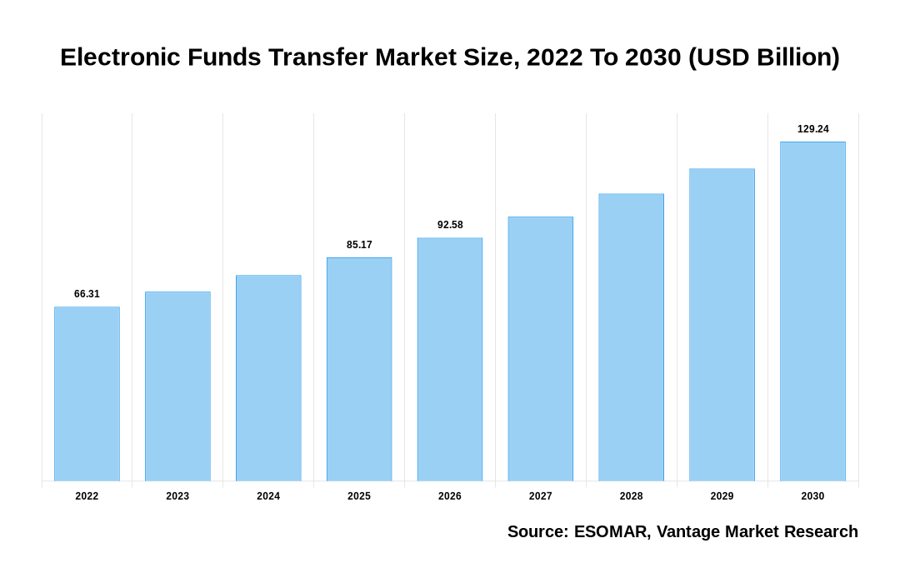  
    Usage for current period time.
4. **The Rise of Online & Mobile Banking:** The late 20th and early 21st centuries saw the digital revolution in banking:  
    **1. Internet Banking:** By the mid-1990s, banks began to provide online banking systems, allowing consumers to undertake banking operations from home, such as transferring payments, paying bills, and checking balances. This dramatically improved client convenience and accessibility.  
   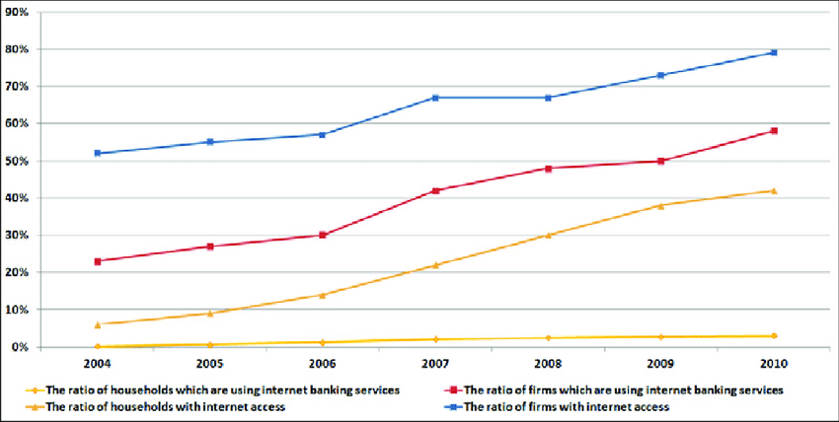  
    **2. Mobile Banking:** The spread of smartphones in the 2000s paved the way for the creation of banking applications, allowing customers to access banking services on the move. Customers could conduct transactions, deposit checks, and manage bank accounts using their mobile devices.  
    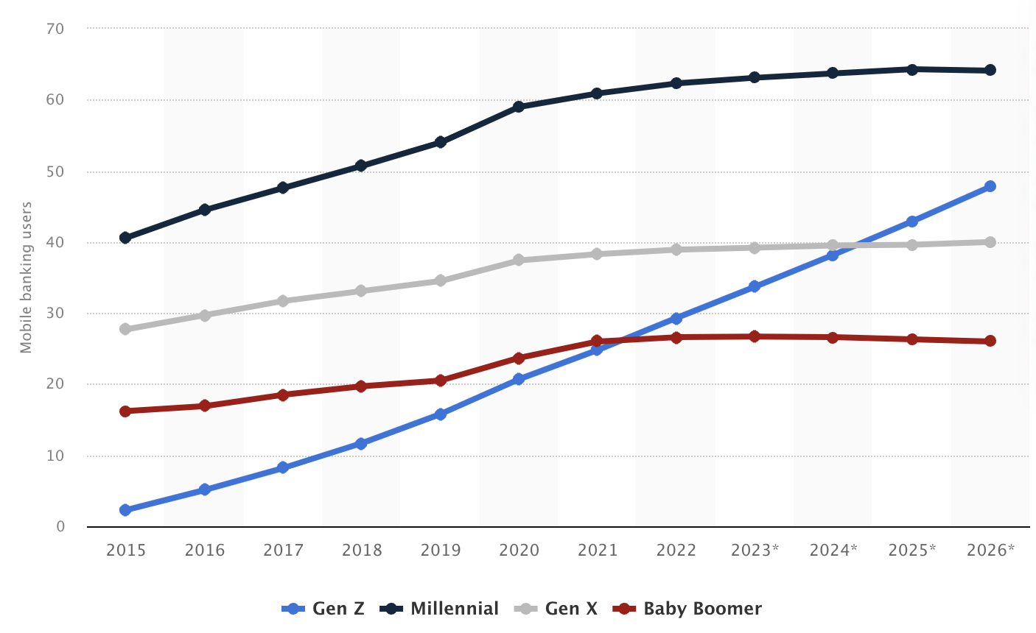  
    **3. Online Security:** With the growth of online and mobile banking, security has become a key concern. Innovations such as two-factor authentication (2FA), encryption, and biometric verification improved digital transaction security, aiding in the prevention of fraud and cyber-attack.
5. **Fintech Innovation and the Future of Banking:** Fintech businesses have recently launched innovative technologies that are altering the financial industry:  
    **1. Blockchain & Cryptocurrencies:** Blockchain technology, which provides decentralised and secure transaction mechanisms, has the ability to minimise fraud while increasing transparency. Cryptocurrencies such as Bitcoin provide alternative payment methods that operate outside of established financial networks.  
    **2. Artificial Intelligence & Machine Learning:** Used to detect fraud, provide customer assistance (e.g., chatbots), and personalise banking services. Machine learning and artificial intelligence algorithms can analyse massive datasets to detect trends and abnormalities, which improves security and user experience.  
    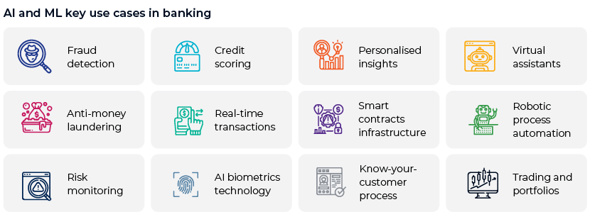  
    **3. Open Banking:** APIs enable third-party developers to create financial institution-specific applications and services. This encourages innovation and competition, which leads to the creation of new financial products and services that improve the consumer experience and broaden access to banking.

**Banking System Resilience During Economic Crises in the U.S.**

There are many economic crises resilience below are few mentioned:

1. **The Great Depression(1929):**   
   **Causes**: The 1929 stock market crash, along with bank failures, reduced purchasing power, and high unemployment rates, set off the Great Depression.  
   **Impact:** Over 9,000 banks collapsed, resulting in enormous financial losses to depositors.  
   **Solution and Recovery:**  
    **FDIC Formation:** The Federal Deposit Insurance Corporation (FDIC) was founded in 1933 to protect deposits and restore faith in the banking industry.  
    **Banking reforms:** To limit risk, the Glass-Steagall Act distinguished between commercial and investment banking activities.  
    **New Deal programmes:** President Franklin D. Roosevelt established the programme to give economic assistance, recovery, and change.  
     
   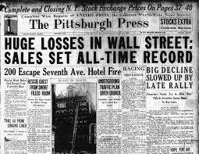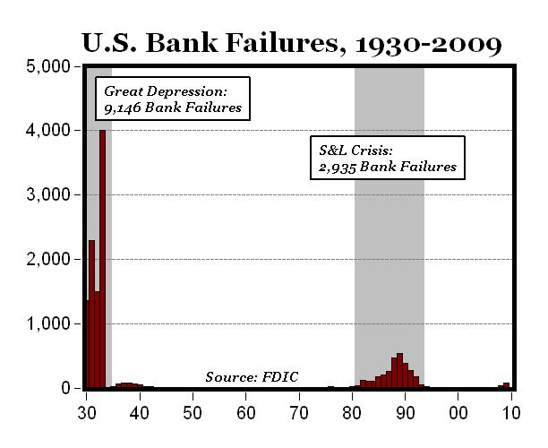
2. **World War II(1939-1945)**:  
   **Challenges:** Banks had to finance the war effort while also managing inflationary concerns.  
   **Solution and Recovery:**  
    **War Bonds:** Banks were instrumental in financing the war by selling war bonds, which served to stabilise the banking industry.  
    **Economic Boom:** The postwar economic boom boosted savings and investments, which benefited banks.  
    **GI Bill:** Facilitated house loans and educational funding through banks, hence helping to economic growth.
3. **Saving & Loan Crisis(1980s)**:  
   **Causes:** Over 1,000 savings and loan organisations failed due to deregulation, high interest rates, and hazardous lending practices.  
   **Impact:** The crisis led to a loss of public trust and considerable financial losses.  
   **Solution and Recovery:**  
     **Resolution Trust Corporation (RTC):** Founded to manage and dispose of the assets of insolvent banks.  
    **Financial Institutions Reform, Recovery, and Enforcement Act (FIRREA):** Enacted in 1989 to revamp the regulatory environment and restore trust in the savings and loan business.  
   
4. **Dot-com Bubble(2000):  
   Causes:** Speculative investments in internet-based enterprises created an unsustainable market bubble.  
   **Impact:** The collapse of the dot-com boom resulted in massive stock market losses and an economic slowdown.  
   **Solution and Recovery:**  
     **Diversification:** Banks were resilient by diversifying and lending cautiously.  
    **Regulatory control:** Increased regulatory control to monitor and manage risks connected with speculative investment.
5. **The Great Recession(2008-2009):**  
   **Causes:** Excessive risk-taking, loose lending rules, and the housing bubble contributed to the financial crisis.  
   **Impact:** The crisis caused the downfall of major financial institutions, a severe recession, and a global economic depression.  
   **Solution and Recovery:**  
    **Troubled Asset Relief Programme (TARP):** Provided cash injections to help stabilise the banking sector.  
    **Regulatory changes:** The Dodd-Frank Act included significant changes to strengthen financial stability and consumer protection.  
    **Stress Tests:** Banks were forced to conduct periodical stress tests to assess their ability to resist economic shocks.  
    **Recapitalization:** Banks enhanced their capital reserves and risk management strategies.  
   A group of people in a building

   Description automatically generated
6. **COVID-19 Pandemic(2020):  
   Challenges:** The epidemic created broad economic upheaval, presenting unprecedented challenges to the financial industry.  
   **Solution and Recovery:**  
    **Digital Solutions:** Banks used digital solutions to sustain customer service and company continuity.  
    Borrowers received assistance through loan forbearance and adjustments.  
    **Government Stimulus Programmes:** Supported government stimulus programmes, such as the Pay-check Protection Programme (PPP), which provided economic assistance.  
    **Monetary Policy Actions:** The Federal Reserve implemented a variety of monetary policy measures to guarantee liquidity in the financial system.

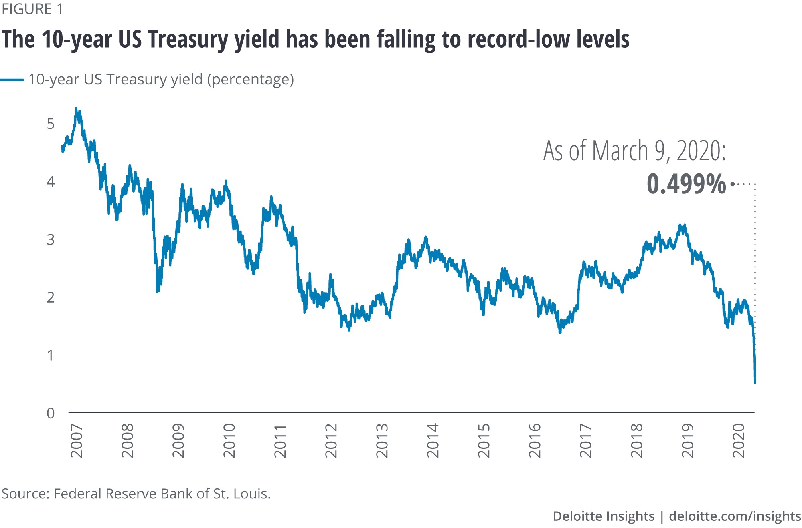

**Conclusion:**The growth of banking technology has changed the financial environment by improving service efficiency and accessibility while creating new dangers and concerns. The resilience of the United States banking sector amid economic crises demonstrates the importance of regulatory frameworks and innovations in preserving stability and confidence. As technology advances, the banking industry must adapt to evolving trends and possible disruptions to maintain resilience and client safety.